Samuel McDowell

7/15/2020

Lab 5.2

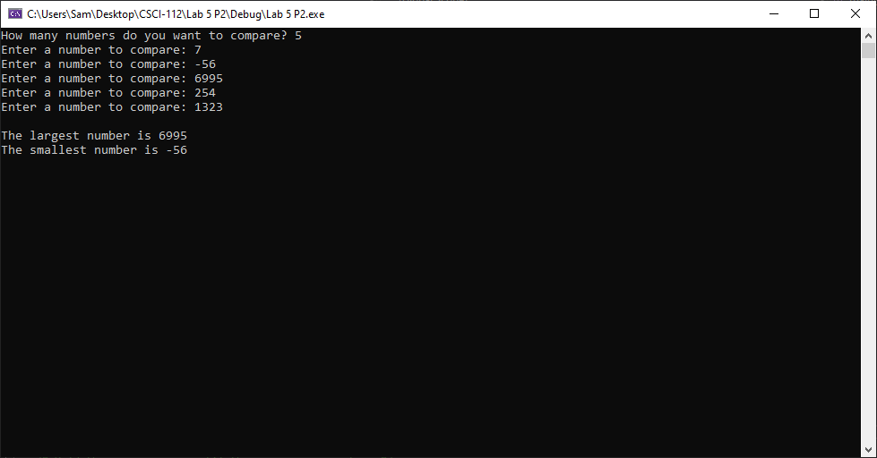

# Transcription:

How many numbers do you want to compare? 5

Enter a number to compare: 7

Enter a number to compare: -56

Enter a number to compare: 6995

Enter a number to compare: 254

Enter a number to compare: 1323

The largest number is 6995

The smallest number is -56